Login to imgur and open developer api

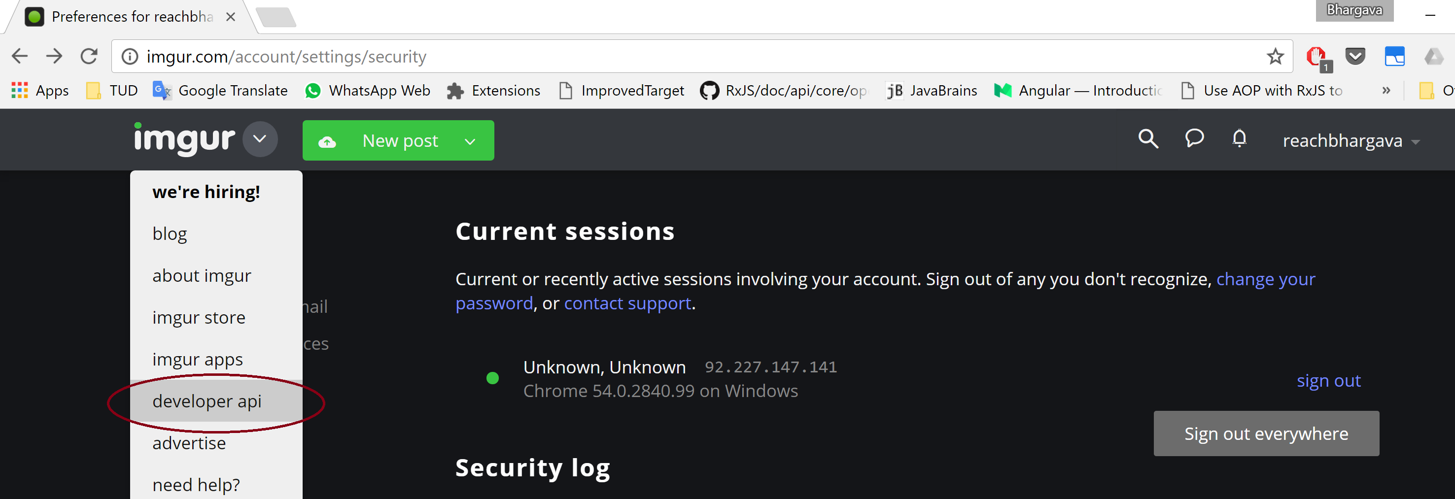

Click on the 'authentication and oauth 2.0' and then on 'Register their application'

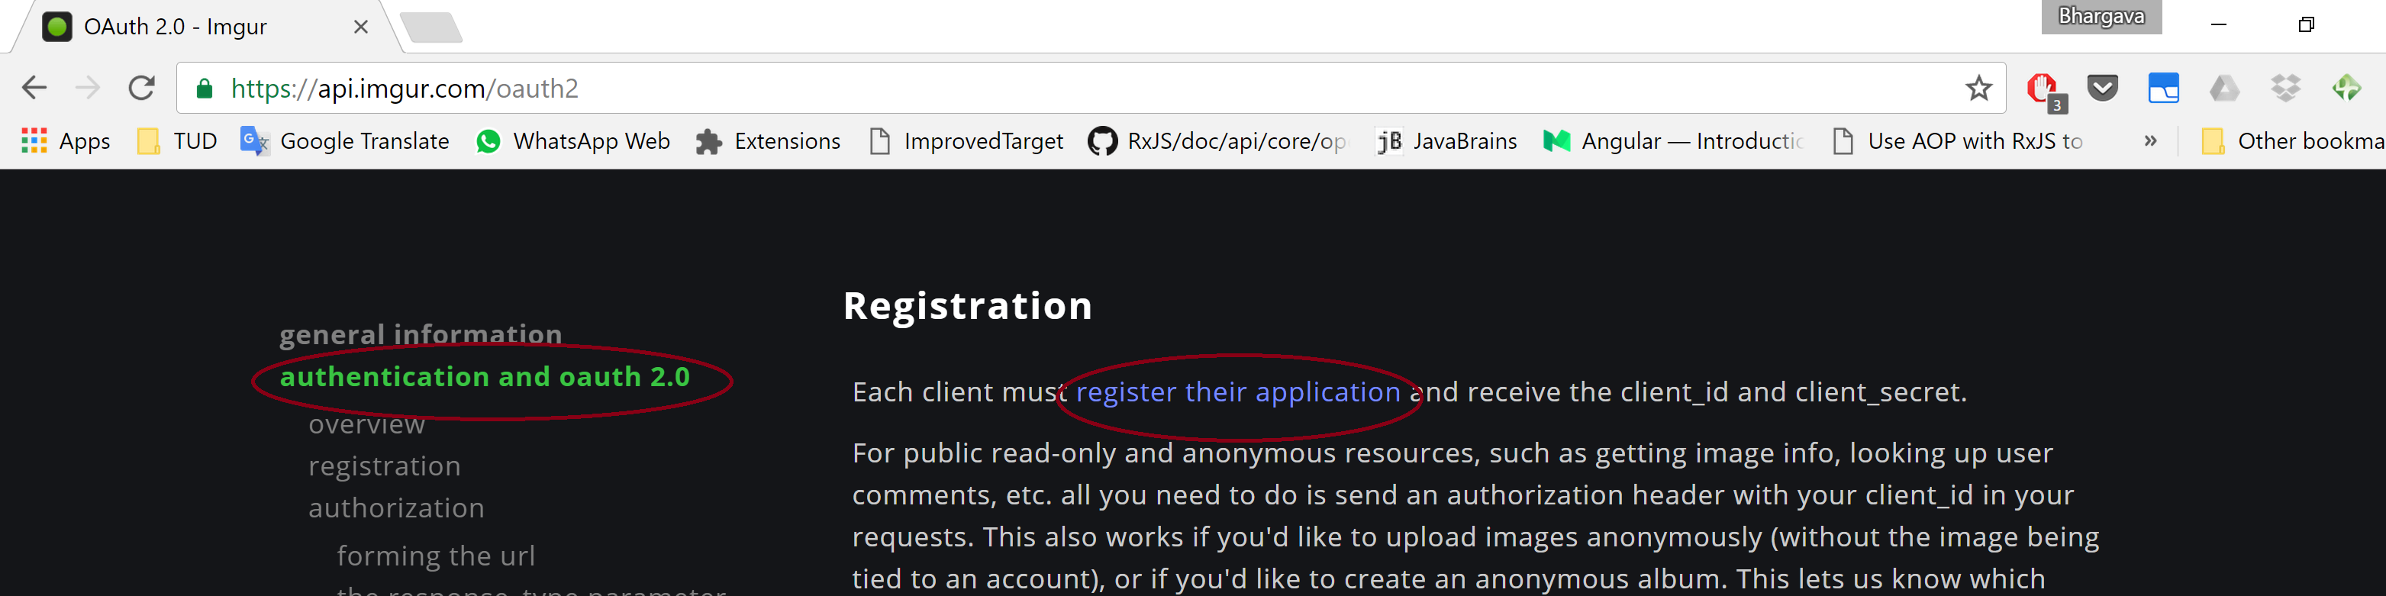
Choose the below.

Make sure that the callback url is as given below: http://localhost:3000/oauth_callback.html

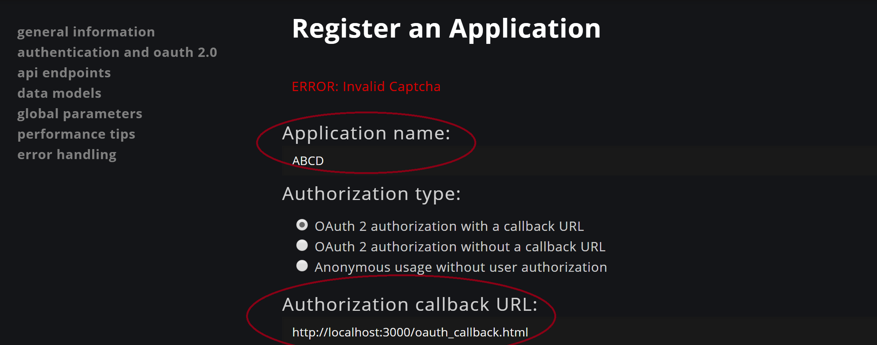

A Client Id is shown in the subsequent page like below. Make note of this.

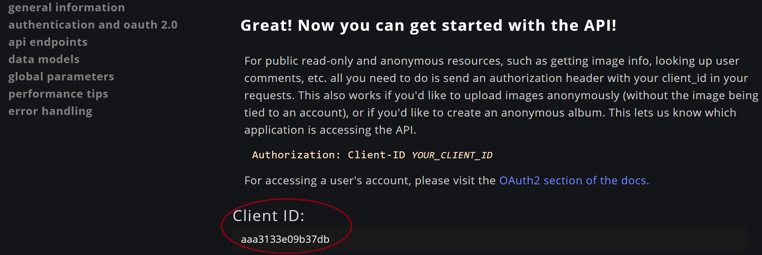

Go to settings --> applications and the entry created should be seen.

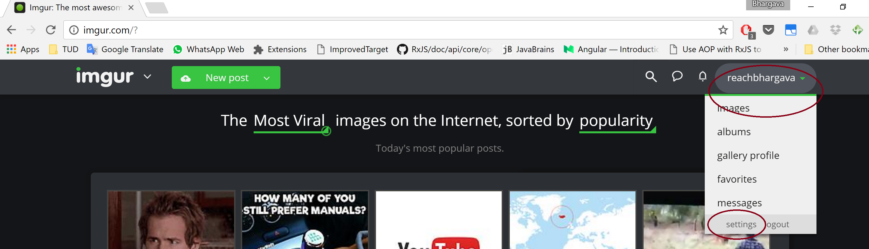
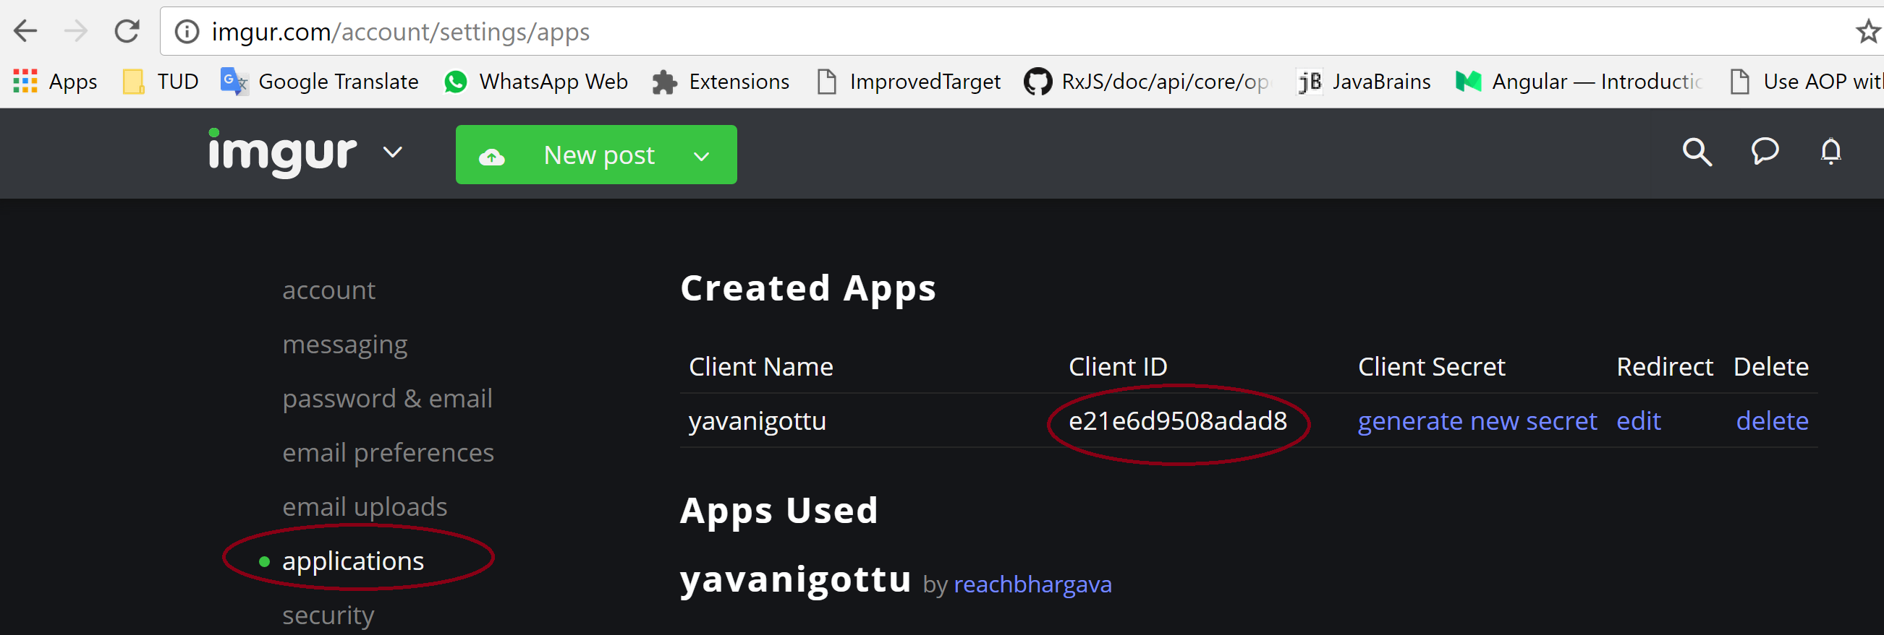

Please scroll down
Please use the highlighted ClientID in the JavaScript file, '/public/js/login.controller.js' like below

